BIOBRIEF

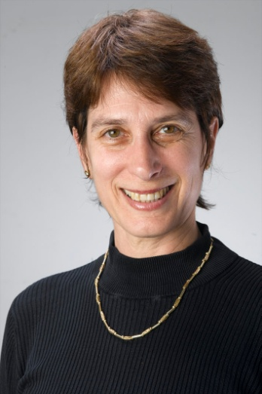
Anat Treister-Goren, Ph.D.,
International Coach Federation (ICF) accredited:

Master Certified Coach (MCC)
Certified Professional Co-Active Coach (CPCC)
Organizational Relationship System Coach Certified (ORSCC)

Anat offers various coaching services including executive coaching, team coaching, facilitation of coach-training programs, designing organizational coaching processes, and more. As an Executive Coach, she works with hi-potentials, senior executives, mid-level managers, women in leadership positions, business owners, partnerships, teams and many more. She leads training workshop focused on coach-approach to management, relationship skills, system and team coach approach, collaborative and individual leadership development, and team leadership trainings. As an Organizational Relationship System Coach, she works with teams, partnerships, family businesses, NGO's and more. References are available upon request.

Anat serves as an international facilitator, coach, and supervisor with world leading schools and programs such as The Coaches Training Institute, The Center for Right Relationship, and Team Coaching International.

The models taught in all of these schools are based on latest findings in fields such as Emotional and Social Intelligences, Appreciative Inquiry, Positive Psychology, Change integration and management, System Work, Deep Democracy, Co-Active Coaching, process psychology, situational leadership, and more. She also works as an executive coach for Intel, and for Ken Blanchard.

Anat’s has worked in the past several years with an extensive number of corporate clients from diverse fields including banks, venture capitals, and investment firms, hi-tech companies such as start-ups and mid to large corporations, retail and food industries, security services, cloth industries, branding, educational institutes and more. She has coached individual managers and leaders who were psychologists, academics, business owners, entrepreneurs, educational leaders, actors and musicians, engineers, finance managers, and more. Geographically, Anat worked with clients from all over the globe in counties such as Spain, UK, Holland, Denmark, Germany, Sweden, Norway, and France, Switzerland, Japan, US, Israel and more.

Anat is committed to creating transformational processes with her clients, and to help them be accountable for obtaining results. The individual and relationship coaching processes with clients often includes a focus on the following aspects: active listening to self, other and the system, conflict resolution, visioning, planning and strategy, creating accountability individually and in a team, mergers, value identification, meta-view skills, effective communication training (awareness of toxic communication and ways of recovery), acknowledgement skills, working with rank and privileges in systems, designing alliance tools, self-management skills, leadership presence and projection, awareness of impact and many more.

Background:
In her past careers, Dr. Treister-Goren has been a lecturer and researcher in areas of Schizophrenic thought disorder, Linguistics and Conversational Analysis, Speech Pathology, Brain and Language, in major universities in the US and Israel for over ten years. She had also worked for several years in the private sector as a senior executive in hi-tech companies focused on speech recognition and artificial intelligence, serving in business development, R&D, and marketing positions. In her more distant past she was a professional singer and actress. Thus, she is well rounded in both managerial and leadership aspects as well as in emotional and social intelligence competencies and skills. Her services combine her education as a coach and facilitator with her expertese from past careers.

Academic degrees:
Ph.D. University of Washington, Neurolinguistics/Speech-Language Pathology, 1991.
M.Sc. University of Washington, Speech Science, 1989.
B.A. U of California Davis, Theoretical Linguistics, 1985.
Coach training education:
Organizational Relationship System Coach Certified (ORSCC), The Center for Right Relationship, USA., December 2008 (ICF accredited school)
Certified Professional Co-Active Coach (CPCC), the Coaches Training Institute, USA, 2006, (ICF accredited school)
Master Certified Coach, ICF accredited.
Team Training Intensive Certification, Team Training International, USA, 2006. (ICF accredited)
Co-Active Leadership program, The Coaches Training Institute, USA, 2006.
Certified Personal and Business Coach, Telem College, Israel, 2004.

